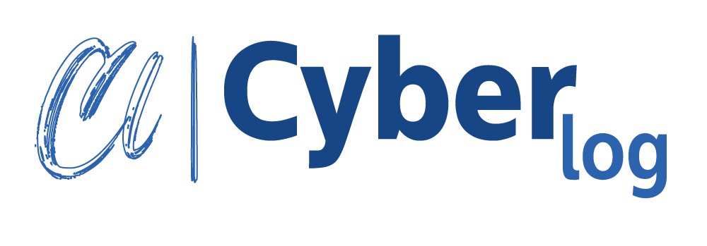
1/6, Block: New - C, Mirpur-1, Dhaka-1216

info@cyberlog.com.bd

www.cyberlog.com.bd 

Invoice No: 14102025-01 Invoice Date: October 14, 2025
Bill To:
Purbachal Apparel Limited
South Panjora, Ward #5, Nagri,
Kaligonj, Gazipur
Phone: +01894719911
Email: info@corespunaprl.com

Quantity | Description | Unit Price (BDT) | Total (BDT)
1 | Website Development Work Order
Subtotal
Advance Payment (50%)
Grand Total

Payment Method:
Bank Name: City Bank Plc.
Account Name: CYBER LOG
Account Number: 1781060001530
Branch: MIRPUR BRANCH
SWIFT Code: CIBLBDDH


Hridoy Mustofa
Founder & CEO
Cybelog

